**Partnership for Green Future Faith Plan**

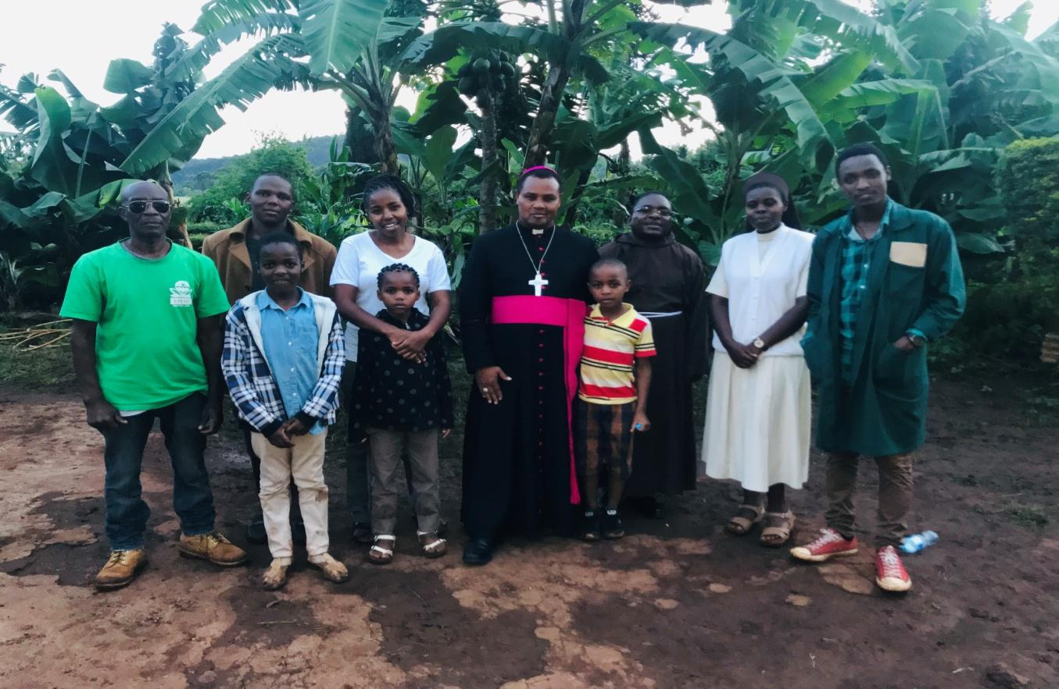

*PGF team with Bishop Antony Lagwan of Mbulu Diocese in one of Environment conservation meeting coordinated by PGF at Mbulu Diocese.*

**Profile of organization**: Partnership for Green Future (PGF) is a Non-Governmental Organization (NGO) founded as a collective effort bringing together different conservation partners and stakeholders at the common ground of implementation. The NGO headquarters is Kibaha, Pwani Plot No 54, hosting several implementing staff. PGF has previously worked with the World Wide Fund for Nature (WWF) in conservation activities, 350.Org in advocating for climate justice and the Laudato’ Si’ Movement and Interfaith platform of Mbulu Diocese in Tanzania in care for creation, nature conservation and restoration. PGF boast the existence of six staff and 45 volunteers from different colleges and Universities andit has three branches in the country. PGF has participated in WWF conservation activities and workshops including development of Pugu Kazimzumbwi, Vikindu and Ruvu Chini forest restoration plan between 2021 and 2022 to boost conservation and restoration initiatives in Tanzania. An active NGO, PGF is working with Local Government Authorities (LGAs) to reach grassroot level conservation and restoration initiatives.

PGF envisions a community of individuals fully aware, responsible and well engaged in care and protection of the earth. The organization plan to continue work with different communities within and outside of Tanzania in addressing and tackling environment related challenges. PGF wants to make sure that the Tanzania community: (i) sustainably used natural resources, (ii) have a well-coordinated and advocacy strategy, (iii) realizes promoted knowledge and management research, and (iv) is actively involved in climate change adaptation and mitigation.

**Our work with Faith Organizations**

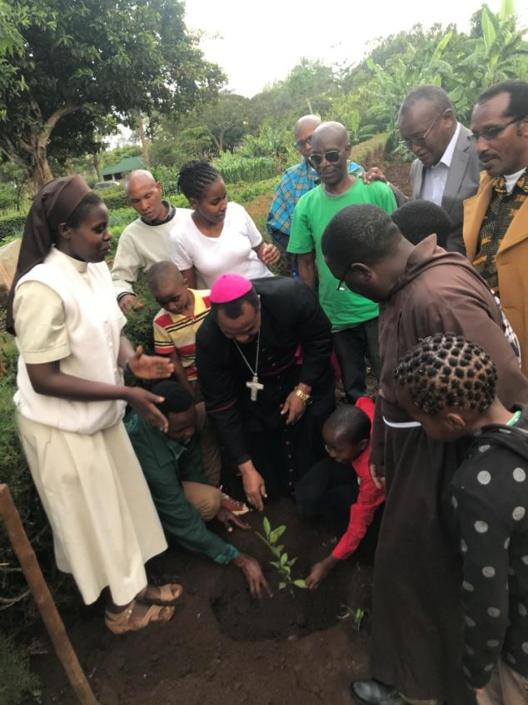 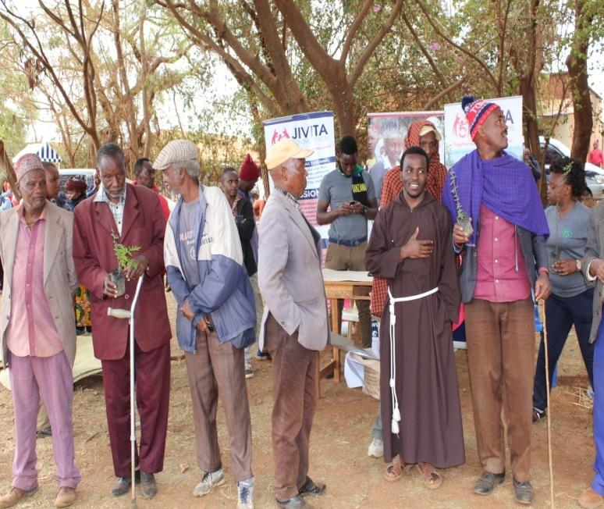

*From left, Bishop Antony Lagwan and other faith leaders planting trees with* PGF/*Traditional faith leaders after the meeting with PGF and other partners at Karatu district.*

PGF also advocates for the care of Mother Earth in line with the call of Pope Francis in implementing Laudato’ Si’ in Tanzania. Tanzania Episcopal conference (TEC) come up with the strategy of greening our Parishes, PGF therefore is working closely with the church and the interfaith networks in greening our common home.

In implementing this project PGF will take advantage of the already established good rapport and networking with interfaith youth and women of different faith. Also this project will impact the TEC strategy of implementing Laudato’ Si’ and greening Tanzania Parishes

**Project Title:** Tree Planting for Climate Justice (TPCJ)

**Project description:** Tree Planting for Climate Justice (TPCJ) is the 10 years project, designed to be implemented at Mbulu Dioceses, located in Northern Tanzania, hosted in Arusha and Manyara administrative regions in Tanzania. PGF in collaboration with faith groups’ organizations and governments’ institution within Mbulu Dioceses intends to implement afforestation activities in fragile catchment areas of lakes Natron, Manyara, and Eyasi. The area has a serious erosion and land degradation that result in lakes siltation, reducing the water depth and resulting into unproductive waters. Lakes are the target for conservation activities because of the livelihood support to the poor communities surrounding the lake. Therefore, conservation of the catchment will not only save the lake but also the livelihood of the people. The project has a double purpose of saving peoples livelihood and conserving nature.

**Goal:** The overall goal of the project is to enhance conservation of the catchment of selected project areas while enhancing the livelihood of the community around.

**Objectives:**

1. Plant 10,000 hectare of threes in 3 different project sites by 2033
2. Enhance community livelihood by planting 3,000 fruit trees to enhance fruit business by 2033.
3. Plant 5000 worth of timber to counteract effect of soil erosion by 2033
4. Reach the community of 8000 people through conservation outreach activities by 2033
5. Realize a reduced siltation rate in the project sites by 2033 (The measure will be determined by specific hydrologists after consultation.)

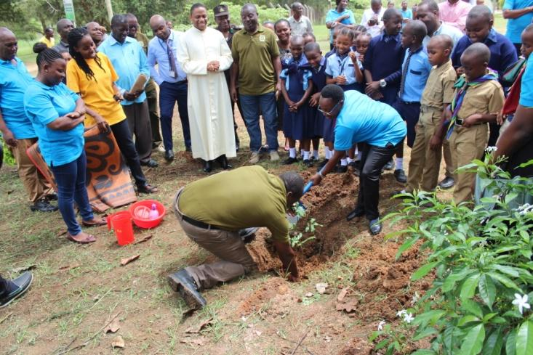 **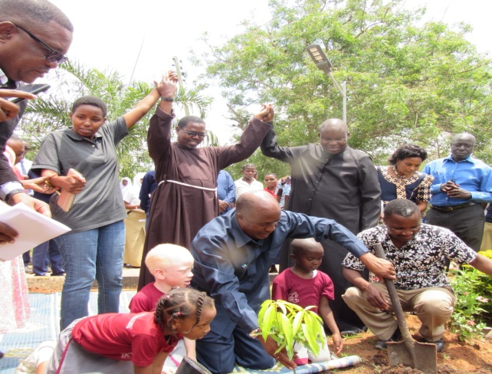***From left*,*tree planting at Kibaha with Tanzania Forest Service(TFS), Tanzania Agricultural Research (TARI), and other partners/To the right Regional Commissioner for Pwani Region planting trees in one of PGF advocacy actions*

**Anticipated outcome**

1. Increase the area under protection by 25%, resulting into increased wildlife dispersal area, triggering additional tourism activities in the areas. The effect of increased protected area will be result into increased carrying capacity of the catchment area, triggering increased reproduction potential to fill in the previously vacant land. This will attract interested investors in tourism investment such as the building of tented camps and rest houses in respective areas.
2. The presence of additional fruits and timber as part of community livelihood, will lead into increased community income. Community income will lead to increased girls and boys school attendance, food security, and decreased malnutrition which all contribute to poverty alleviation in addition to environment conservation.
3. Decreased siltation and increase water depth will contribute to increased lakes productivities. Increase fish productivity will ensure protein source to surrounding community, ensuring food security in the community. Furthermore, with climate change lingering and causing water insecurity for animal, decreased siltation will increase the lakes water retention capacity of the lakes. This will in turn increase water security around the conserved area and food security to wild animals and birds including Thomson's flamingos and ostrich.

**Project site:** The project aims to undertake its activities in Mbulu Diocese in Manyara and Arusha region. The focus will be Mbulu landscape which included the catchment areas.

Mbulu Diocese is positioned in Manyara Region which is very near to Mbulu Highlands with forested mountains like Guwang which are tourist attractions and assist in rain formation. There is also a hotspring Hhaynu, LakeManyara, Lake Manyara National Park lake Babati and mount Hanang’. The highlands lie mostly in Mbulu district of Manyara Region, extending northward into Karatu District of Arusha. The elevation of the plateau is 1500 to 2300 meters; the mean annual rainfall is 1000mm or more in the highlands, higher than the surrounding lowlands, and mostly results to soil erosion, resulting into siltation of Lake Manyara. Therefore, this project will reduce siltation of Lake Manyara.

In Mbulu Diocese, there are four big lakes which are Lake Manyara, Eyasi, Natron and Lake Babati. The region is classified as dry and semi dry area with the average rainfall of 650mm at lowlands, temperature range from minimum annual average of 16℃ in July to a maximum of annual average of 27℃. The vegetation is characterized by savanna grassland; there is also forest woodlands and grasslands on alluvial soil, vegetation of deep gorges.

**Flora and fauna**

Of great interest in this region is the wildlife.It contains about 1.9million big size wildlife herds, and over 1.5Millionlesser flamingos at Lake Eyasi and Natron. Lake Natron is classified as UNESCO World Heritage site.

The Gnu, Zebra and the Thomson Gazelle are three important species found in the region. There is also a big population of elephants, other kinds of gazelle and antelopes, buffalos, and rhino.There are also several medium and small size animals like carnivores (lions, leopards, hyenas, cheetah, jackals, African wild dogs, and small carnivores), as well as birds, such as ostrich.

**Parks and protected areas**

The Mbulu District is surrounded by national parks and different protected areas such as Tarangire National Parks, Manyara National parks and Ngorongoro conservation area.

**Community around Manyara Region and Mbulu Diocese**

Manyara region is inhabited by various ethnolinguistic groups and communities which includes Assa, Gorowa, Kw’adza, Mgugwe, Dotooga, Massai and Barabaig and Irakw which is the largestethnic group in the region.

**Total area of project :**The project anticipates covering 10,000 hectares of trees over aten-year timeline. That is an area of 1,000 hectares area of planted trees in Mbulu Diocese.

**Project activities by year’s series:**

**Year 01**

1. Launch the project: This will include making the project known to all project stakeholders. The activity is geared at avoiding duplicity of activities by other partners and promoting complimentarily to attain the same goal. This further includes promoting the project to the Nation Tanzania Forest Service (TFS) regional focal persons whose national mandates included prioritization of tree planting in respective areas. TFS focal person will also act as an advisory body to the project.
2. Technical working group: Involves sitting down with tree and soil experts and sort types of tree for specific suitable soil regimes and slopes.
3. Community engagement: Translates into NGO involvement in one of the quarterly meeting of the village to introduce the project to village communities. The step will be followed by closely working with Village Environmental Committees and identification of project champions in respective villages. Project champions will in future be used to roll up project activities in the absence of project personnel in the villages.

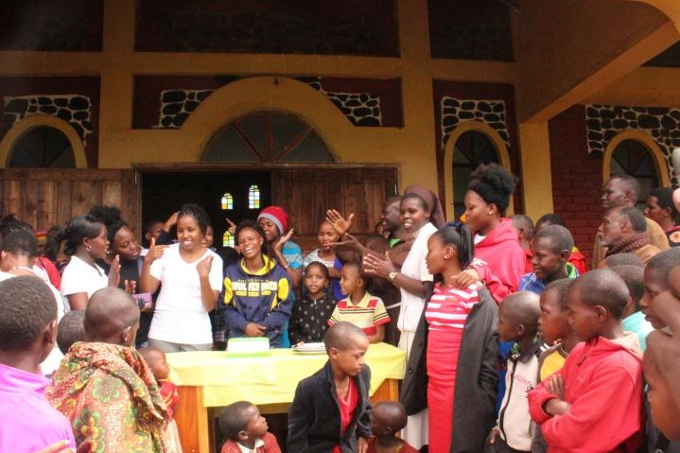 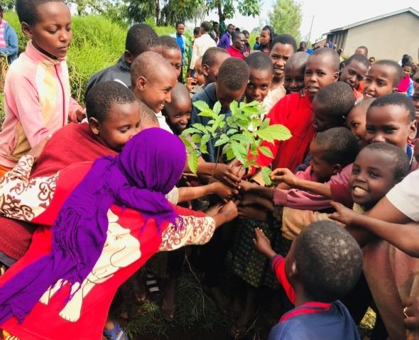

***PGF celebrating St Francis of Asisi, Patron of ecology at Rhotia –Karatu district***

1. Seedling establishment: This will include seedling sites establishment will the TFS. Based on TFS experience, the project will be advised to either purchase ready grown seedling for deployment or create its own seedlings based on cost -benefit analysis in respective regions.
2. Conducting baseline survey: The baseline survey conducted will make sure that all benchmark information prior project set up is well recorded depending on the set of indicators which will later be used to measure progress. This exercise will ensure performance baseline information is made available for each project progress indicator.

**Year 02- 08**

1. Deployment of seedling to site and planting activities: Engages transportation of seedling to sites for planting. In this process, each village project champion will lead respective village environmental committees for the exercise. The work will enable decentralization of activities in project sites whilst maximizing good governance trick to archive immediate results.
2. Monitoring project progress: we will engage frequent travels to the project sites to monitor tree survival rates. The two years survival record of trees will be used to determine the success of the project in two pilot sites. Monitoring will also include collecting all information on the siltation rate of the lakes.
3. Scale up of activities in other areas: The lessons learnt, success and failures, will be used to redirect efforts into the scaling up of project activities into other project areas. The lessons from pilot areas will ensure success and new areas and minimize the risk of failure of project jeopardy by local politicians.

**Year 9 – 10**

1. Work with Local Government Authorities and Tanzania Forest Service (TFS) district authorities to mainstream project activities under government authorities.
2. Conduct end of project evaluation: This will record all results and success stories under the auspices of the project.
3. Conduct the knowledge management plan workshop and documentation to keep important knowledge base for tree planning additional activities to be conducted by the organization in the future.

**Project partners:** Tanzania Forest Fund (TFF), The Diocese of Mbulu, Inter Faith Karatu network, Women Against Poverty Organisation (WAP), Foresters, Karatu district, Mbulu district, Communities of farmers and pastoralist of Arusha and Manyara Region, Faith Invest and WWF Tanzania

**Project implementation strategies:** The following are the project implementation strategies according to respective project objectives:

**Objective 01**: Plant 10,000 hectare of threes in 3 different project sites by 2033

Strategies:

1. Approach TFS with the proposal to plan trees
2. Conduct an appropriate analysis of suitable trees for the areas
3. Confirm the suitability of the soil type of specific proposed tree types
4. Check the weather partner and possibility to use drip irrigation for pilot areas to adapt to the effect of climate change
5. Establish seedling
6. Roll out tree planting activities after community engagement.

**Objective 02**: Enhance community livelihood by planting 3,000 fruit trees to enhance fruit business by 2033.

**Strategies:**

1. Work with TFS focal person to engage the community in the identification of high value fruits
2. Conduct the market value for specific trees
3. Identify champions ready to embark on the task in the villages
4. Roll out tree planting activities in respective villages.
5. Monitor the results and document appropriate livelihood benefits from the planning.

**Objective 03**: Plant 5000 worth of timber to counteract effect of soil erosion by 2033

Strategies:

1. Conduct a quick survey to highlight high value, fast growing improved timber trees that can mature in the period of 10 years.
2. Attribute the tree to people livelihood, confirming if the timbers are tradable
3. Embark on timber seedling establishment.
4. Roll our timber tree planting.
5. Secure a competitive bidding strategy to maximize the harvest cycles
6. Make the harvest and sales.

**Objective 04**: Reach the community of 8000 people through conservation outreach activities by 2033

Strategies:

1. Consult the LGA on the number of people and distribution in the project areas
2. Consult other project partners to understand the baseline knowledge of communities around on conservation
3. Identify community strength, weaknesses and threats on conservation issues
4. Determine the best way to conduct community reach out (Radio, or PA systems etc)
5. Deploy community outreach programs
6. Observe behavioral change of the community by comparing it with baseline indicators.

**Objective 05**: Realize a reduced siltation rate in the project sites by 2033 (The measure will be determined by specific hydrologists after consultation) .

Strategies:

1. Consult Institute of Marine Science on measuring the baseline of siltation in respective project site lakes.
2. Identify the lakes catchment areas, upstream and downstream the rivers emptying into the lakes
3. Work with both upstream and downstream communities to identify suitable trees for both conservation and livelihoods
4. Embark on community based upstream and downstream common planting trees campaign
5. Deploy tree planting activities during the wet season
6. Monitor tree grown in respective fields.
7. Conduct the reduced amount of siltation in respective lakes
8. Conduct increased productivity through proxy indicators, for example increased fish catch.
9. Conduct effect of improved income and livelihood through KAP (Knowledge, Attitude and Practice) surveys

**Sustainability of the Project**

* **Program sustainability.**  Program activities will be mainstreamed to LGA activities just prior the project phases out. Through the project champions group formed, which will also include existing environmental committees, information from the project on the progress, lessons and areas of performance will assist the local government authorities and Tanzania Forest Services (TFS) mainstream project activities during and after project phase out. This information will later be used by the government to scale up tree planting schemes in other areas of the country after the project phase out.
* **Financial sustainability**. PGF will engage in the advocacy of conservation activities at community level. Conservation activities are in turn expected to attract tourism activities in the region and around national parks. Conservation activities members in villages who are also environmental committees’ members are members of the Wildlife Management Association (WMAs) from the park area. The project will make sure that, financial benefits of the WMA reach and continues to impact the development of WMAs and village environmental committees for future conservation work activities.
* **Institutional sustainability.** PGF will use the results from this project to showcase its ability to undertake conservation and livelihood inclusion interventions. Results will be shared through a number of platforms, including webinars and website. The strategy will assist PGF to either attract new donors for the conservation intervention and / or maintain the good relationship with existing donors through an additional fund to scale up existing conservation intervention in either Tanzania or elsewhere in the world. With or without donor fund, PGA will continue to use host information from the project to widely share with youth related stakeholders for use through a website, creating new opportunities and partnerships for future youth work.

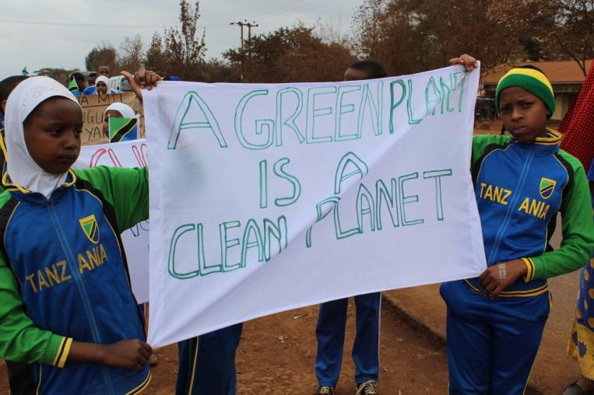 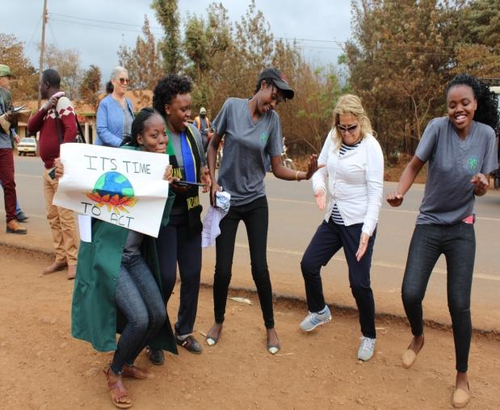

***Young generation, Partners and community of Karatu advocating for forest conservation and restoration.***

**Target beneficiaries**

**Primary targeted beneficiaries:** An estimated 27,000 rural villages from selected districts will be targeted because they have limited options compared to urban counterpart. These beneficiaries are target because they have limited livelihood compared to the urban counterparts who have a wide variety of options. Planting trees and harvesting timber, fruits, and realizing increased food and water security due to fish stock and water retention times will improve the respective population livelihood. The project will make sure that 60% of project beneficiaries are women and vulnerable youth.

**7 Secondary targeted beneficiaries:** An estimated 564 secondary beneficiaries will be targeted by the project, These will include district committees who will be benefit from trainings and an opportunity to experience tree planting interventions; tree planting champions selected from villages who will be the champions of conservation advocacy after project induction training; Tanzania Forest Agency staff who will be engaged from the project start to the end in trees planting and members of Wildlife Management Areas (WMAs) who will get an opportunity to interact with project staff, drawing an experience to benefit conservation in respective villages.

.

**Addressing Gender issues:** The project plans that, 60% of the beneficiaries will be women and girls in order to fast track poverty eradication around the community. The following strategies will be used to make sure that the project has women beneficiaries: -

1. Trainings offered will make a counting of women to make sure that all project capacity building strategies take on board women, not only present, but active participation.
2. The selection of village tree planting champions will take on board the representation of women to make sure that women voices are heard throughout the interventions.
3. Tree distributed in villages will take into account number of women that get especially fruit and/or timber fruits. This is to ascertain that, on harvest, women and girls get to harvest fruit and /or timber and therefore account for direct beneficiaries.
4. The project team is led by the woman. The team will make sure that, more women assistants are brought on board as assistance officers and therefore directly benefit from project implementation experience offered by the project.

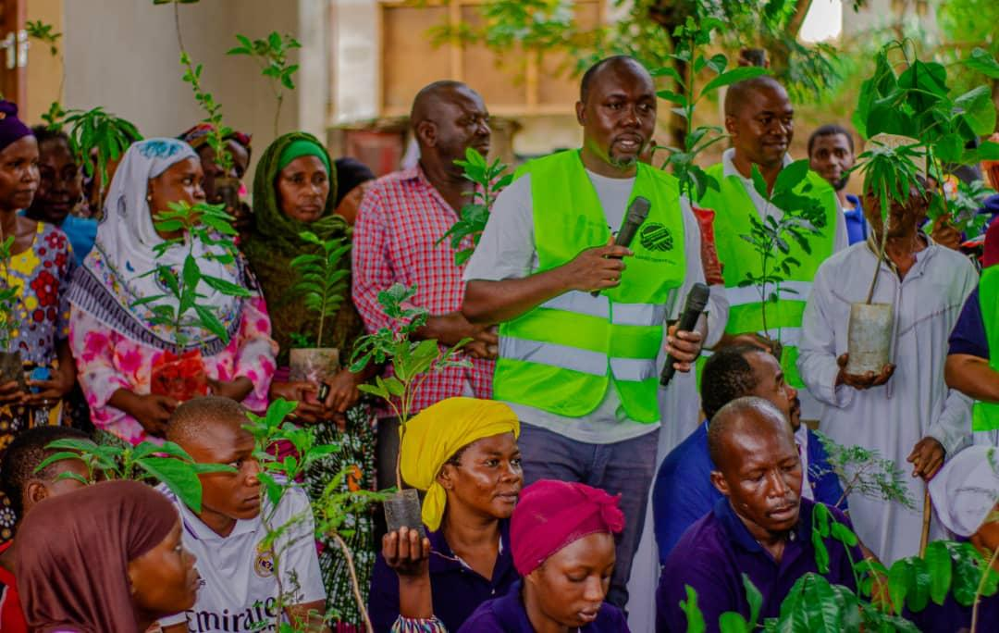

*Partnership For Green Future in collaboration with Kibaha Interfaith Network, celebrating Earth Day through tree planting at Tanzania Research Institute compound, May 2023, Kibaha Pwani.*

In Collaboration With Women Against Poverty Organization, Partnership For Green Future Is Implementing For The Year 2021-2023 Managed To Start A Tree Nursery At Kitanga In Kisarawe District.

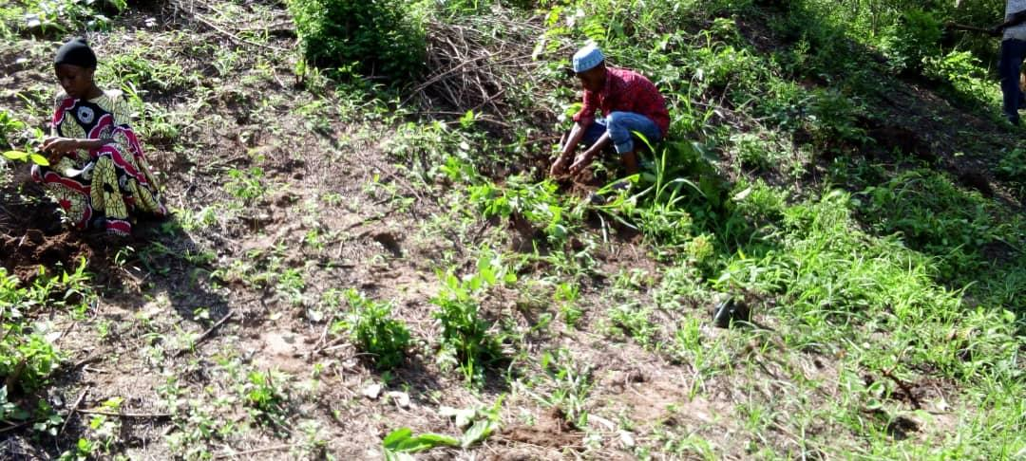

*Tundwi Songani Mangrove Restoration Project with Community Members.*

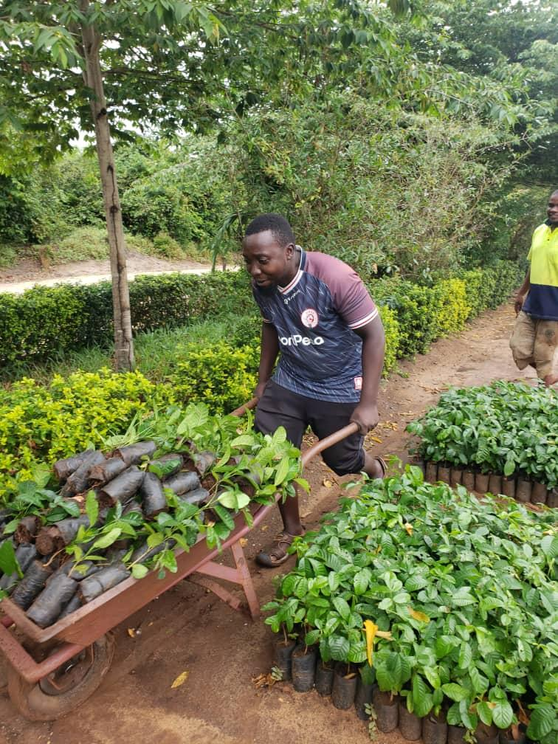 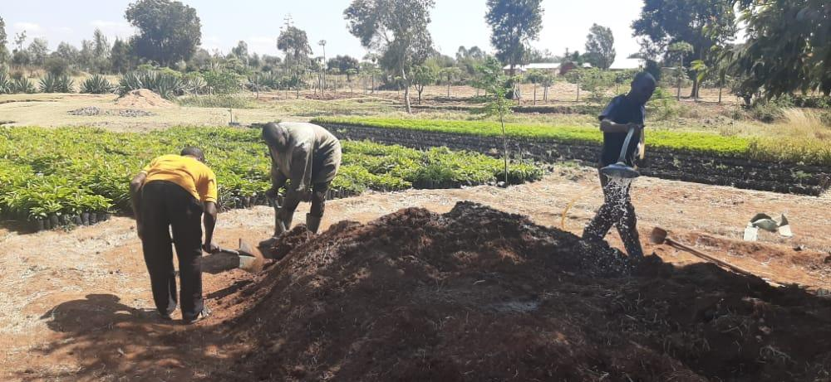

*Volunteers Working At Kitanga Tree Nursery Garden*

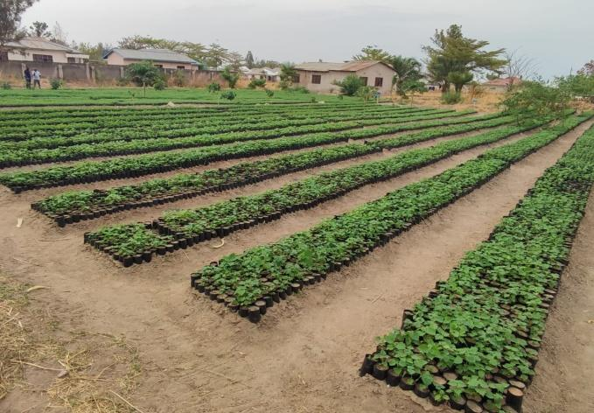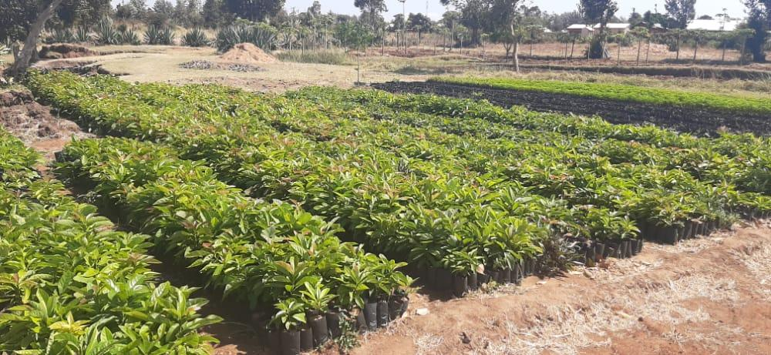

*Tree Seedlings At Kitanga Tree Nursery Garden.*

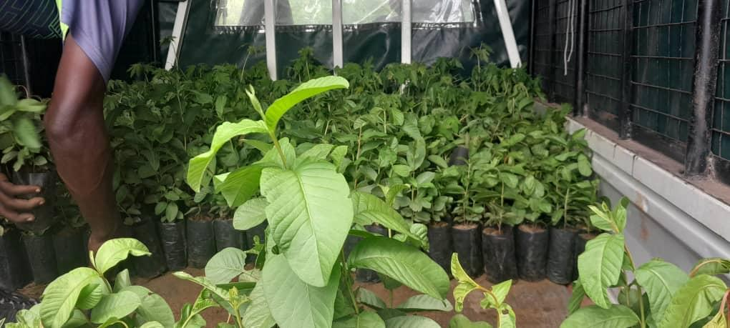

*Fruit Tree Seedlings Transported From Kitanga Tree Nursery Garden.*