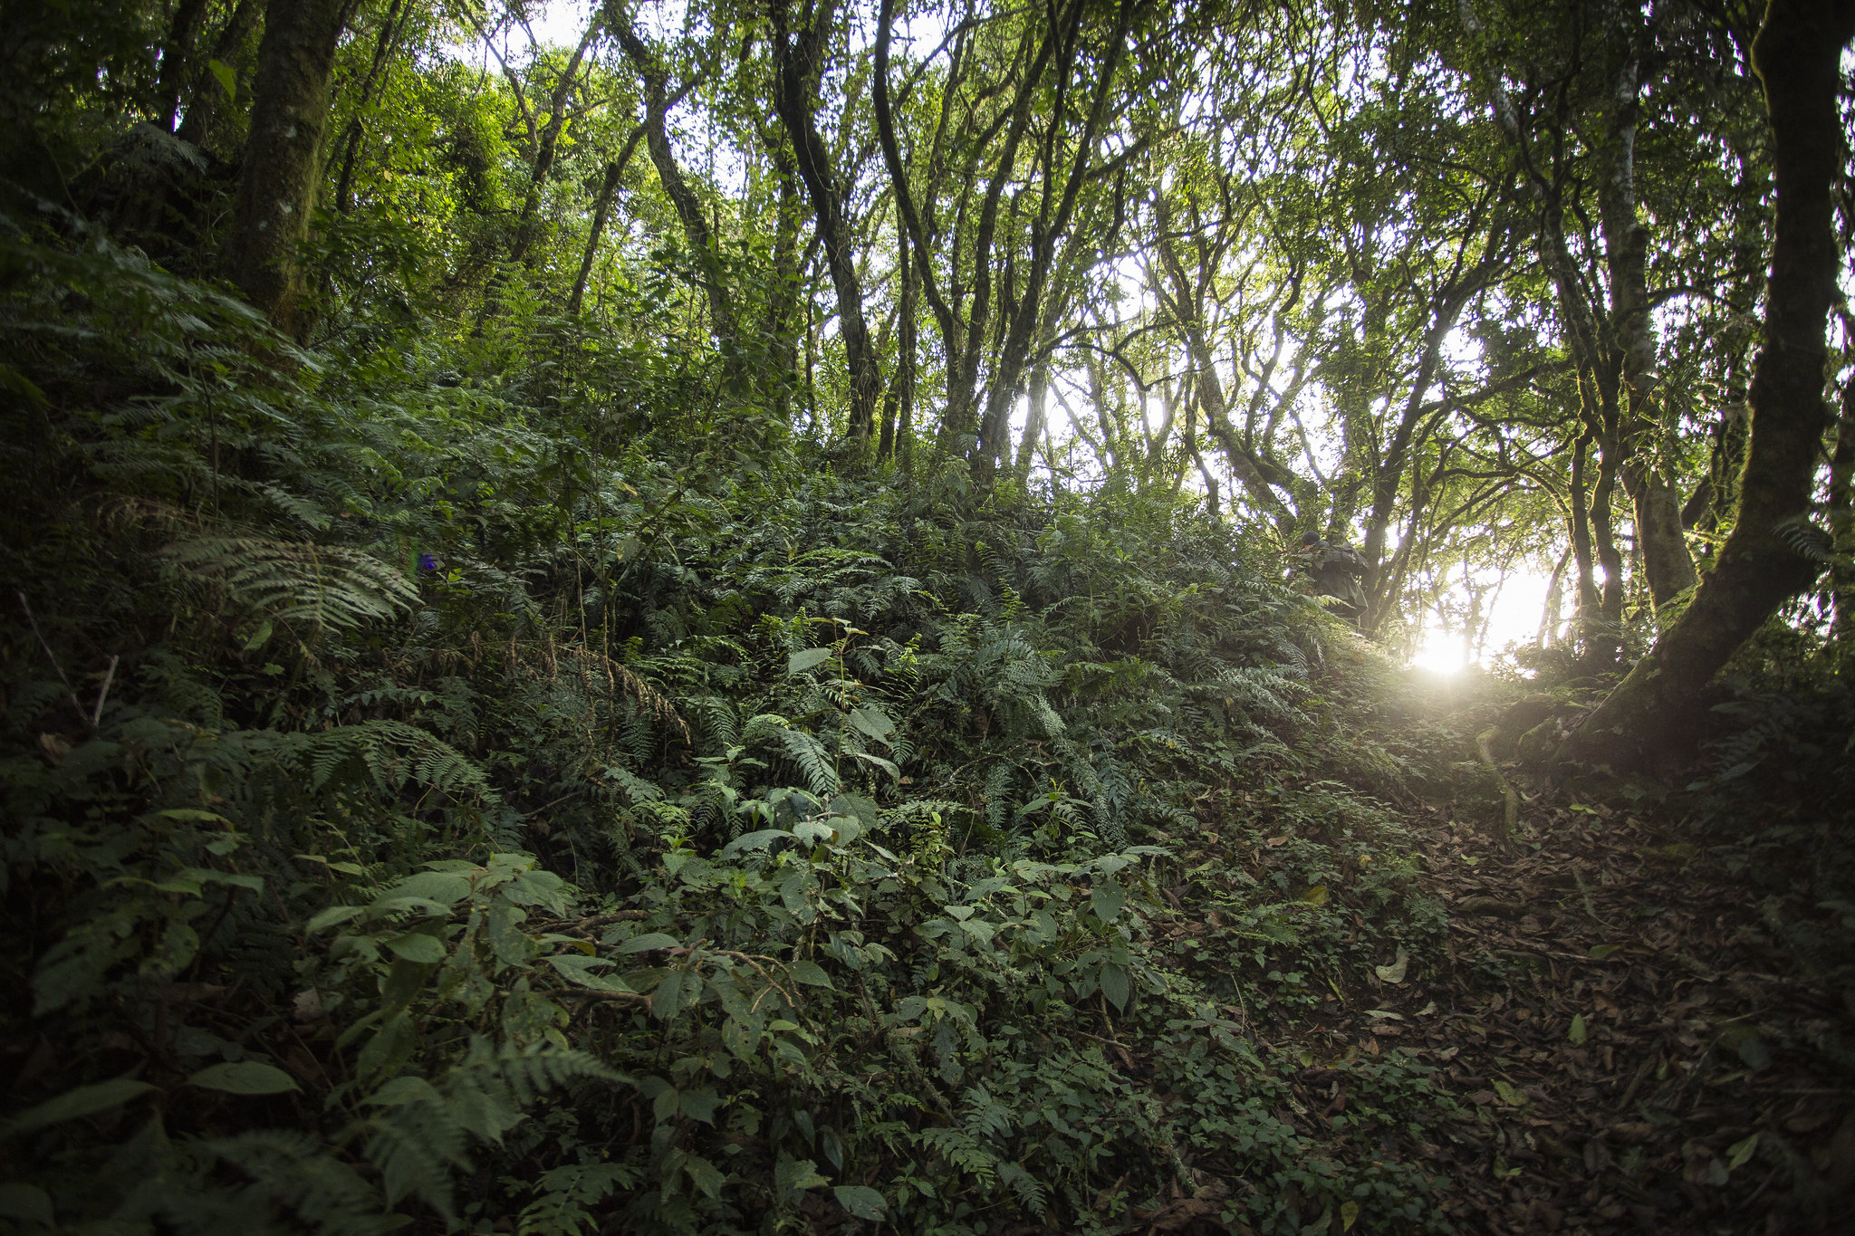
SEVEN YEAR FAITH PLAN BY SOPRODE
DEMOCRATIC REPUBLIC OF CONGO

This seven-year action plan initiated by SOPRODE to be supported by FaithInvest is essentially devoted to culture of tree growing for the conservation and restoration of ecosystems in the provinces of South Kivu province (Territories: Walungu, Kabare, Kalehe and Mwenga) and North Kivu province (Territories: Nyiragongo and Rutshuru) in the Democratic Republic of Congo (DRC).
It outlines activities to be undertaken to address the challenges of deforestation, biodiversity loss and ecosystem degradation in accordance with established standards.
This plan aims to support/strengthen the fight that SOPRODE has been leading since its creation, against climate change and biodiversity loss in the DRC.
- Problem description
Recurrent wars in South Kivu and North Kivu provinces have led to overexploitation of natural resources and imbalance of the ecosystem. These conflicts are at the origin of the devastation of large areas of land, especially since they lead to massive human migrations affecting the natural and agricultural ecosystems concerned and their biodiversity in the host areas.
Thus, in a context of conflict and in the desperate struggle to obtain food and fuel, a growing number of men and women living in generalized destitution have no other resources than to exploit the available natural resources, thus causing a degradation of ecosystems and the loss of biodiversity.
However, it is noted that the deforestation increasingly perceptible whose consequence of land degradation remains deplorable, affects daily the socio-economic life of rural populations.
It is this context that motivates SOPRODE to propose the present seven-year plan to face the above mentioned challenges.
The DRC has ratified the Paris Agreement as part of the REDD+ process consisting of reducing its greenhouse gas emissions by 17% between 2020 and 2030 as a Nationally Determined Contribution (NDC). As a result, the DRC has committed to restoring 8 million hectares of forests under the Bonn Challenge and to contributing to climate change mitigation and adaptation.
At the national level, the Constitution of the Democratic Republic of Congo (DRC), in its Article 53, recognizes "every person has the right to a healthy environment conducive to his or her full development and the State shall ensure the protection of the environment and the health of the population".
II: Methodological approach and strategies
a) Documentary analysis
b) Outreach visits
c) Meetings and workshops
d) Tree growing programs

III. Objectives
- Contribute to the improvement of the forest ecosystem for the well-being of communities to 75% by 2029;
- Reduce the abusive cutting of trees to 30% by 2029 and thus promote natural regeneration, thus increasing vegetation, biodiversity and carbon storage;
- To popularize and adopt techniques for integrated soil management from the year 2023;
- Improve agricultural soil fertility to 35% through agroforestry by 2029;
- Improve the conservation and restoration of ecosystems and reduce the loss of biodiversity to 35% through the reconstitution of forest capital, by 2029 to reverse the degradation faced by the territories concerned in South Kivu and North Kivu.
IV. Activities
- Advocate for the effective implementation of a bushfire control program in South Kivu and North Kivu;
- Advocate for the effective implementation of a policy to promote public, private, community and public/private plantations/afforestation in South Kivu and North Kivu;
- Promote agroforestry in rural areas with high population density in the territories concerned in South Kivu and North Kivu;
- Sensitize local communities and/or indigenous peoples on the policy of promoting reforestation and agroforestry;
- Make the choice of species;
- Acquisition of inputs;
- Prospecting for sites,
- Site development
- Set up of tree nurseries;
- Distribution of seedlings;
- Tree growing campaigns
- Maintenance of the plantation ;
- Monitoring and evaluation
V. Indicators
- A 7-year reforestation program exists, starting in 2023;
- By 2023, at least 200,000 ha of forestry capital is constituted and/or reconstituted;
- From the year 2023, techniques for integrated soil management are popularized and adopted;
- Arable land is covered with trees of different species, namely fertilizer trees and 30% fruit trees, by 2029, which create additional income for the communities;
- By 2029, the organic carbon stock increases by 10,000 and 15,000 PgC.

